IDEATION PHASE – 3. EMPATHY MAP CANVAS
Date | 8/10/2026
Team ID | 9100Orbit
Project Name | Implement Client Script & UI Policy (Incident)
Maximum Marks | 4 Marks

Empathy Map Canvas
This empathy map is a project-context map prepared from the Incident-management problem and workflow described in the uploaded project document. It is not presented as a transcript of a user interview.

Target User / Persona
Primary user: ServiceNow Incident record user / service-desk staff member who creates or updates Incident records.
SAYS  “I need to enter the Incident correctly.”  “I need to know which fields are required.”  “I should be warned before an invalid record is saved.” | THINKS  “What information is mandatory for a High Impact Incident?”  “Why did this field become read-only?”  “Will the system prevent me from saving incomplete data?”
DOES  Creates and updates Incident records.  Changes Impact and other fields.  Attempts to save records.  May edit fields from a list view. | FEELS  May feel uncertain when rules are not visible.  Wants clear guidance and quick feedback.  Feels more confident when validation is automatic.

Pains
- Incomplete Incident records.
- Inconsistent or incorrect field values.
- Manual checking before submission.
- Unexpected field behavior without clear rules.
- Unauthorized or unintended State changes through list editing.

Gains / Needs
- Complete and valid Incident records.
- Automatic enforcement of business rules.
- Clear error messages and immediate feedback.
- Consistent Urgency for High Impact Incidents.
- Controlled editing and improved data quality.

How the Proposed Solution Responds
User Need | ServiceNow Mechanism | Expected Benefit
Conditional field control | UI Policy + UI Policy Actions | Fields become mandatory/read-only under defined conditions.
Automatic urgency consistency | onChange Client Script | Urgency is automatically set to High when Impact is High.
Prevent incomplete save | onSubmit Client Script | Save is blocked when Assigned To is missing for High Impact.
Prevent direct list State edit | onCellEdit Client Script | State changes through list editing are blocked.
Restore normal behavior | Reverse if false | Controls are reversed when High Impact condition is no longer true.
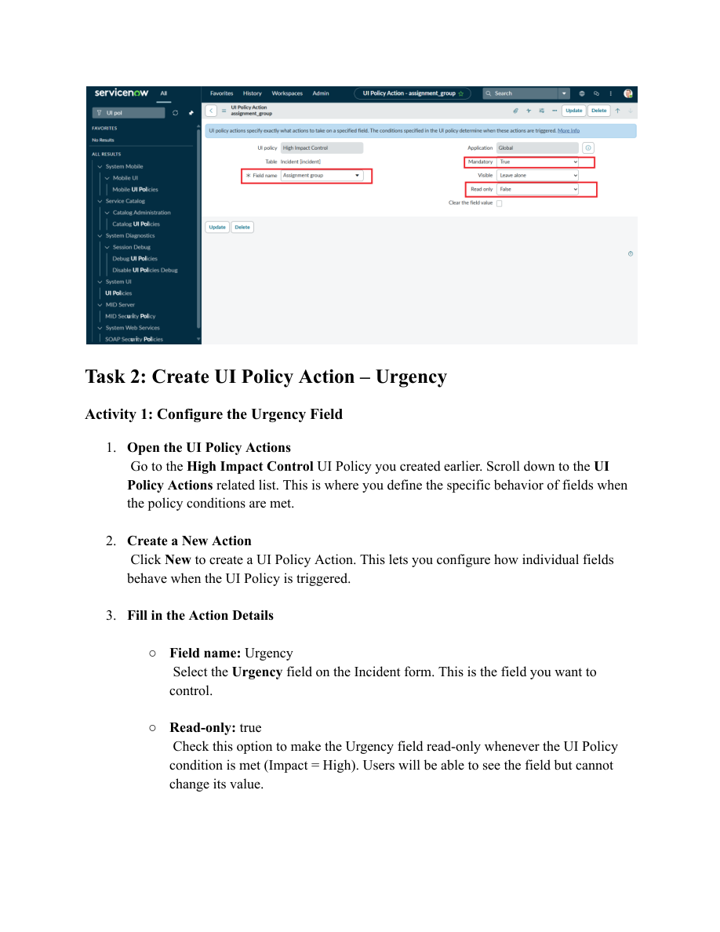
Figure 1. Urgency UI Policy Action from the uploaded project PDF.
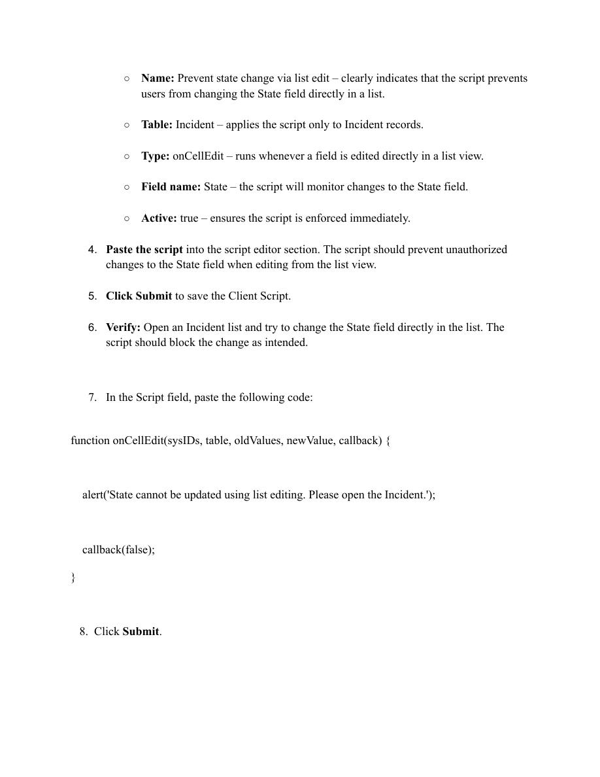
Figure 2. onCellEdit Client Script configuration from the uploaded project PDF.
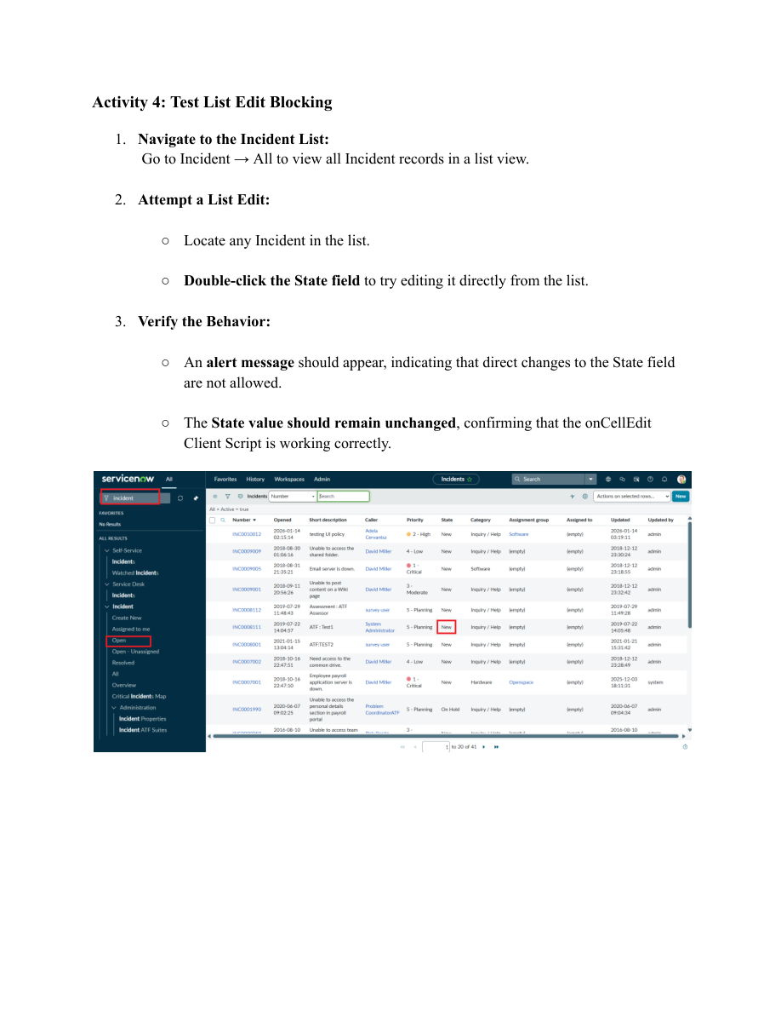
Figure 3. List-edit blocking test from the uploaded project PDF.

Empathy Map Summary
The user needs a guided Incident form that reduces manual checking and prevents invalid submissions. The project addresses these needs through conditional UI Policies, onChange automation, onSubmit validation, and onCellEdit restrictions. The intended result is improved data quality, consistency, and form usability.

